

**Machine Learning Applications for Business**

**Individual Assignment 1**

**Submitted by**

Ankit Dwivedi (M22MS093)

MBA’24

**Course Instructor**

Dr. Bhargab Chattopadhyay

**About the dataset**

**Problem**

Bob has started his own mobile company. He wants to give tough fight to big companies like Apple, Samsung etc.

He does not know how to estimate price of mobiles his company creates. In this competitive mobile phone market, you cannot simply assume things. To solve this problem, he collects sales data of mobile phones of various companies.

Bob wants to find out some relation between features of a mobile phone (ex: RAM, Internal Memory etc) and its selling price. But he is not so good at Machine Learning.

In this problem you do not have to predict actual price but a price range indicating how high the price is. Our goal is to identify a relationship between different features of a mobile phone, such as RAM and internal memory, and its selling price. Our objective is not to predict the actual price of a mobile phone, but to determine a price range that indicates how high the price is likely to be. We hope that with the help of a machine learning model, we can better estimate the pricing of our mobile phones and compete effectively with other players in the market.

**About Dataset**

The dataset consists of 2000 rows and 21 columns.

Data information.

1.battery_power- phone battery capacity is the amount of electricity that a fully charged battery can deliver to a stand-alone device before it is completely discharged. Simply put, this indicator can give a rough idea of how long the phone will work on its own before it is completely discharged.

2.blue - the presence of bluetooth.Bluetooth is a short-range wireless technology standard that is used to exchange data between fixed and mobile devices over short distances using UHF radio waves in the ISM bands from 2.402 to 2.48 GHz and build personal area networks (PANs). It is mainly used as an alternative to wired connections, to share files between nearby portable devices, and to connect mobile phones and music.

3.clock_speed-speed at which microprocessor executes instructions.Clock speed is the number of operations that the processor performs per second. The higher it is, the more processor performance. The number of processor cores and cache size are also important. Now even the cheapest dual-core processors come with a frequency of 3.5 GHz - this is the level of a multimedia or gaming computer of the middle class. If this indicator is higher, the possibility of overclocking the processor and the number of cores also increase.

4.dual_sim-has dual sim support or not.The term Dual Sim in a phone or smartphone means support for two SIM cards, one of which you can use, for example, for personal calls, and the second for work. Many modern smartphones support two SIM cards.

5.fc-front camera mega pixels. The front camera is a camera that looks like a small eye, which is located on the front of the phone, in the same place where the sensors are installed (that is, at the top). Other manufacturers did not pay due attention to the characteristics of the front camera in the smartphone, as they hardly interested people. The front camera was used exclusively for making video calls.

6.four_g-has 4G or not. 4G is a generation of mobile communications with increased requirements. It is customary to refer to the fourth generation as promising technologies that allow data transmission at a speed of up to 100 Mbps to mobile (with high mobility) and up to 1 Gbps to fixed subscribers (with low mobility).

7.int_memory-Internal Memory in Gigabytes. Internal Storage is a data storage on a smartphone where important data is found: the operating system (OS), installed applications, photos, videos, documents and other files.

8.m_dep-mobile Depth in cm.

9.mobile_wt-Weight of mobile phone.

10.n_cores-Number of cores of processor.The total number of cores in a single processor in an Android smartphone is typically eight (most iPhone upgrades have six). "The number of nuclear strikes on smartphone performance." big.LITTLE, in turn, stands for simply: there are cores that are more productive (large) and less productive (small).

11.pc-Primary Camera mega pixels. The number of megapixels of a camera sensor describes the image resolution that can be captured with this camera. For example, cameras with a 12 megapixel sensor can take photos with a resolution of 4200x2800 pixels, an 8 megapixel camera allows you to take pictures with a resolution of 3264x2468 pixels.

12.px_height-Pixel Resolution Height.

13.px_width-Pixel Resolution Width.

14.ram-Random Access Memory in Megabytes.Random Access Memory (RAM) is the link between the processor and the playback system because it contains temporary information necessary for running applications to run.

15.sc_h-Screen Height of mobile in cm.

16.sc_w-Screen Width of mobile in cm.

17.talk_time-longest time that a single battery charge.

18.three_g-has 3G or not.Mobile communication of the third generation is built on the basis of packet data transmission. Networks of the third generation 3G operate on the border of decimeter and connected to the network. They allow you to organize videotelephony, watch movies and individual content on your mobile phone.

19.touch_screen-has touchscreen or not. A touchscreen, in fact, is a touch glass that works according to a simple scheme: touching the observer allows you to realize any functions or symptoms of exposure.

20.wifi-has wifi or not. Wi-Fi is a wireless networking technology that allows devices such as computers (laptops and desktops), mobile devices (smartphones and wearables), and other equipment (printers and camcorders) to access the Internet.

21.price_range This is the target variable with value of 0(low cost), 1(medium cost), 2(high cost) and 3(very high cost).

**Variables**

**Response Variable:**

price _range – The range of mobile phone prices and is categorized into 0,1,2,3.

**Predictor Variables:**

1. battery_power - Total energy a battery can store in one time measured in mAh
2. blue - Has Bluetooth or not
3. clock_speed - speed at which microprocessor executes instructions
4. dual_sim - Has dual sim support or not
5. fc - Front Camera mega pixels
6. four_g - Has 4G or not
7. int_memory - Internal Memory in Gigabytes
8. m_dep - Mobile Depth in cm
9. mobile_wt - Weight of mobile phone
10. n_cores - Number of cores of processor
11. pc - Primary Camera mega pixels
12. px_height - Pixel Resolution Height
13. px_width - Pixel Resolution Width
14. ram - Random Access Memory in Megabytes
15. sc_h - Screen Height of mobile in cm
16. sc_w - Screen Width of mobile in cm
17. talk_time - longest time that a single battery charge will last when you are
18. three_g – Has 3G or not
19. touch_screen - Has touch screen or not
20. wifi – Has wifi or not

**STEP 1 : IMPORT LIBRARIES & LOADING DATASET**

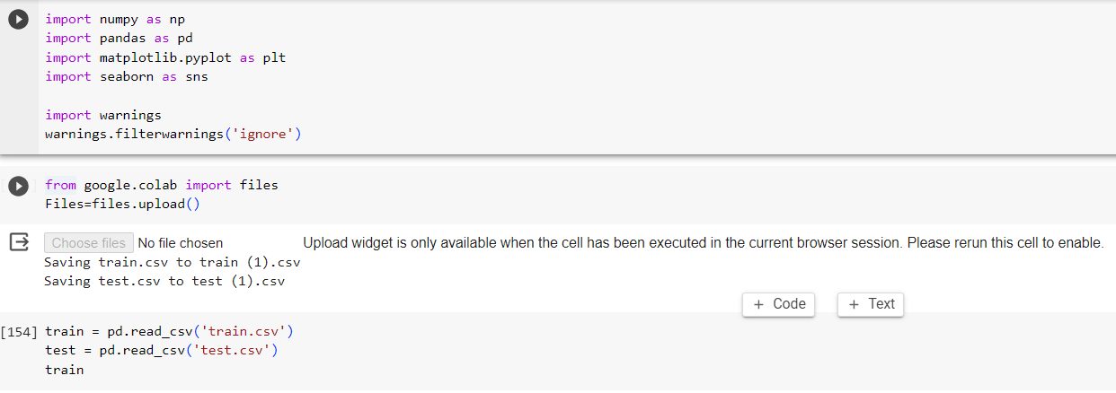

**STEP 2 : Checking null, Dropping Duplicate values and EDA**

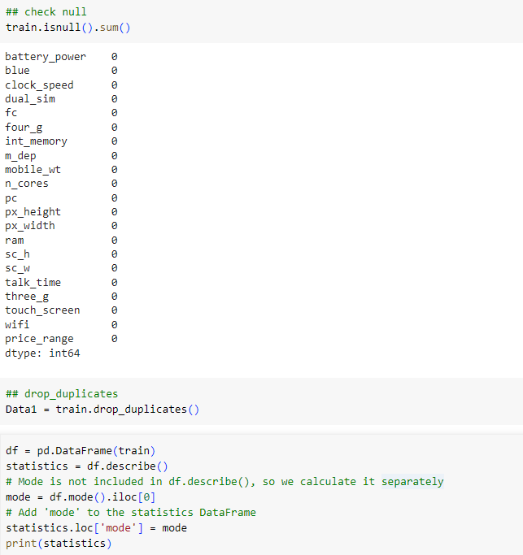

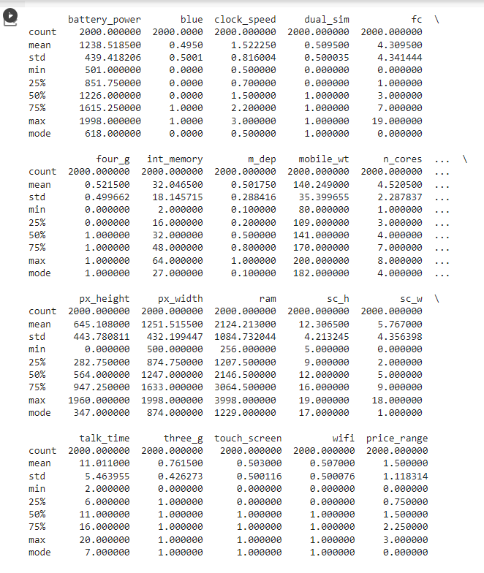

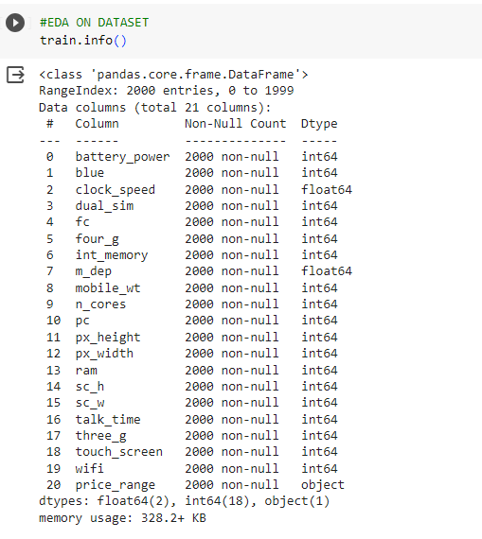

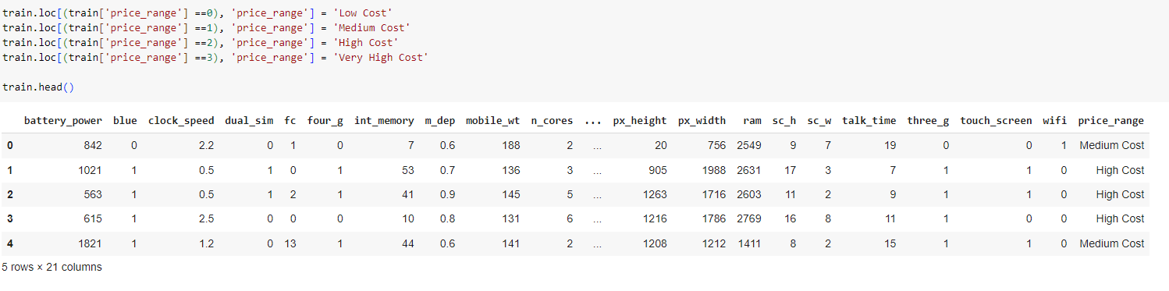

**STEP 3 : Data Visualisation**

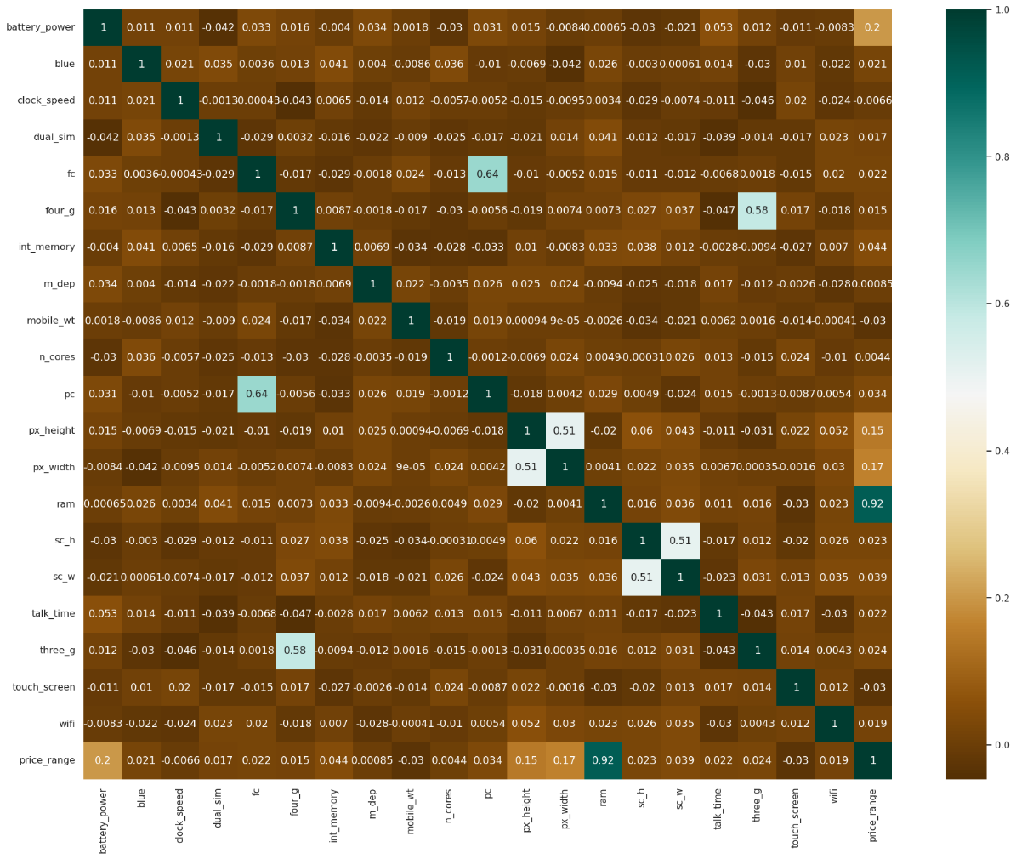

These values have the highest correlation to price:

* ram
* battery power
* screen dimensions
* internal memory

**BOX PLOTS**

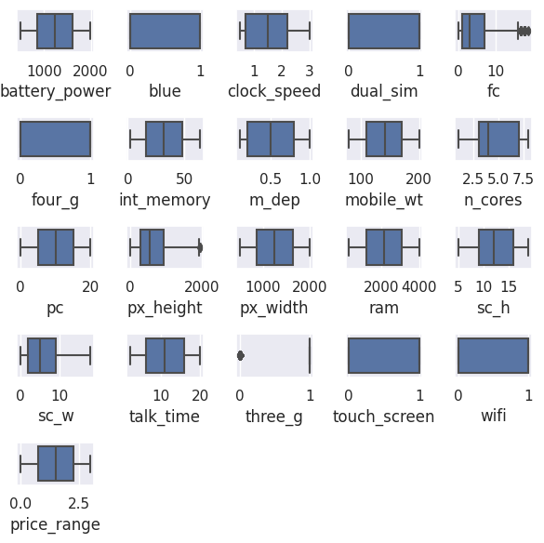

**Histograms**

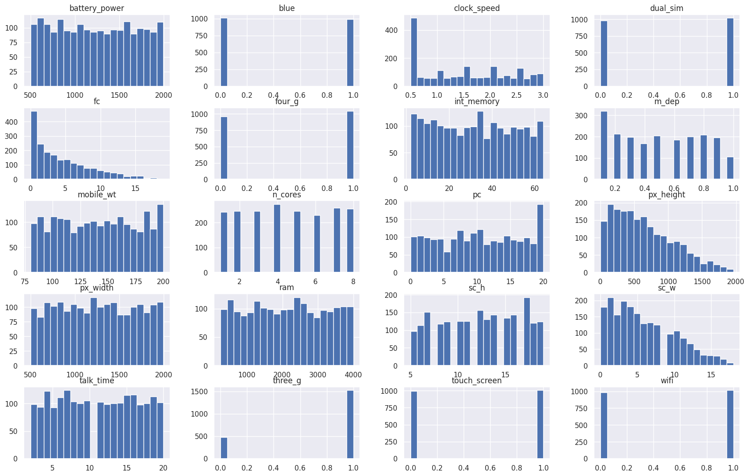

**Cost Distribution of Mobile Phones**

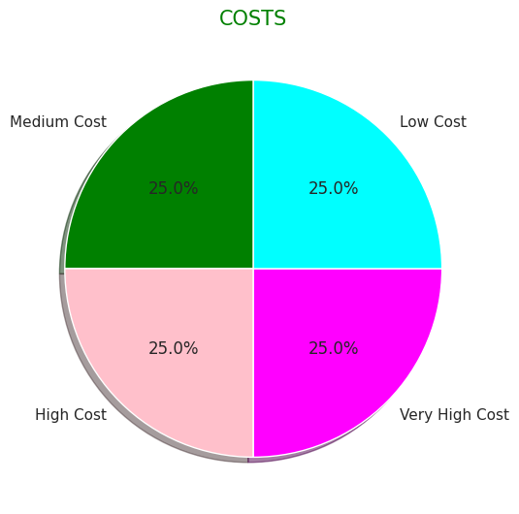

**Effect of Ram Capacity on Price**

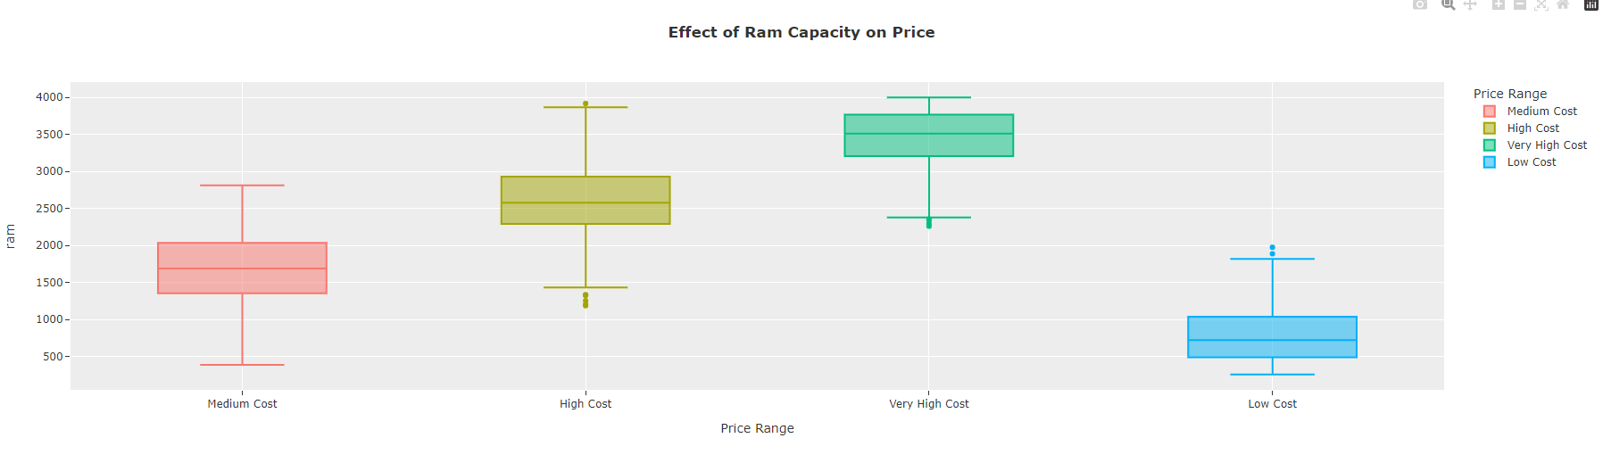

**Battery Power by Price**

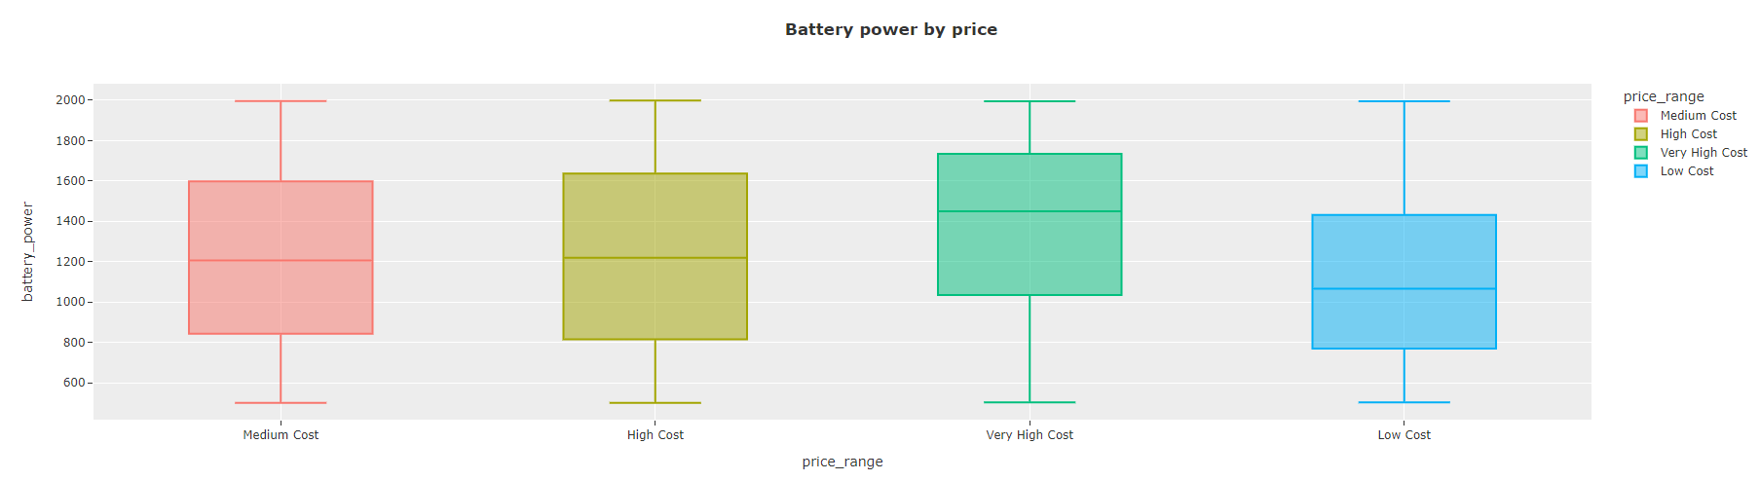

**Internal Memory Vs Price Range**

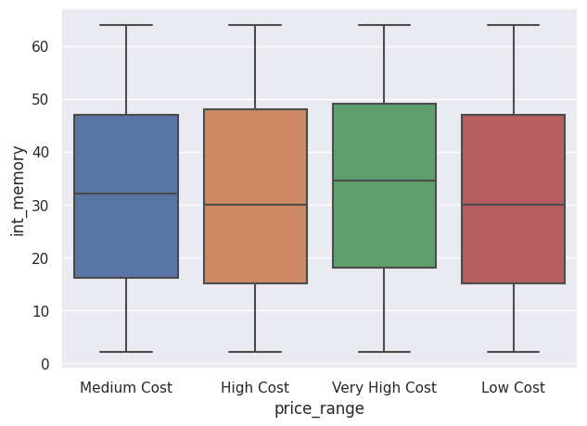

#RESULT

#As the battery power increases, we can say that the price increases.

#The higher the RAM capacity, the higher the price.

#The price goes up when the phone has 3G.

#The percentages of cheap, medium, expensive, very expensive phones in the dataset are equal.

**STEP 4 : Data Preprocessing & Outlier Removal**

**Biasness**

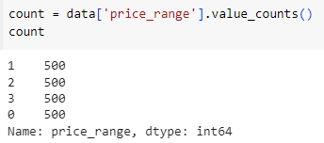

All the classes are equal across the data set. So, there is no bias found in the dataset.

**Multi-Collinearity**

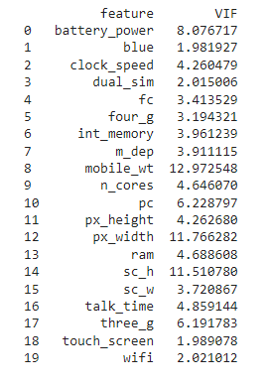

The Variance Inflation Factor values help in identifying the features that are highly correlated with other features. High VIF values (typically greater than 10) indicate high multicollinearity and may suggest that those features should be considered for removal or further analysis in your regression model to avoid multicollinearity-related issues. Lower VIF values indicate lower multicollinearity.

So, from the dataset, mobile_wt, px_width, sc_h has a high VIF value indicating high multi collinearity and battery_power, pc, three_g also has significant multi collinearity.

**STEP 5: Training , Testing , Splitting & Model Fitting**

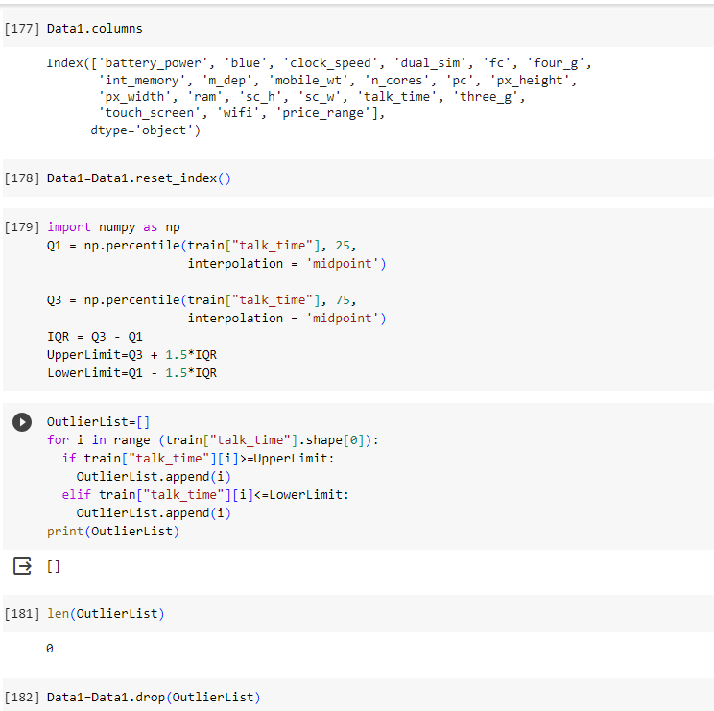

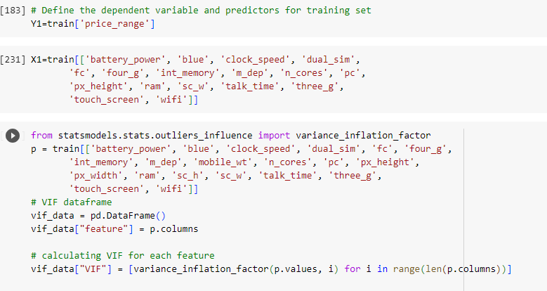

**Step6 : Model Evaluation**

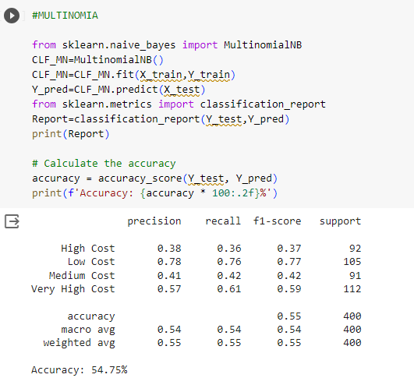

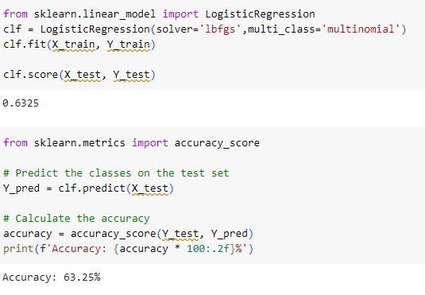

**2. Support Vector Classifier**

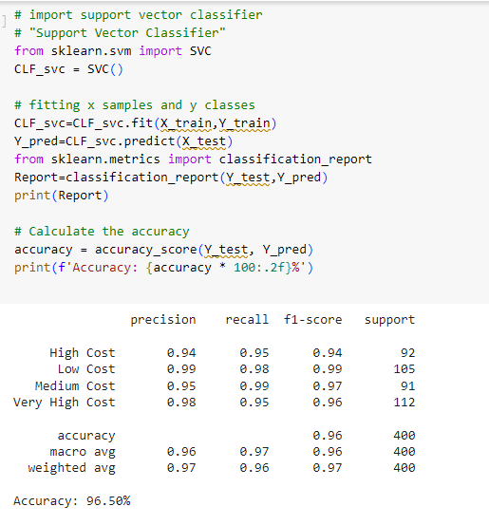

**3. Random Forest Classifier**

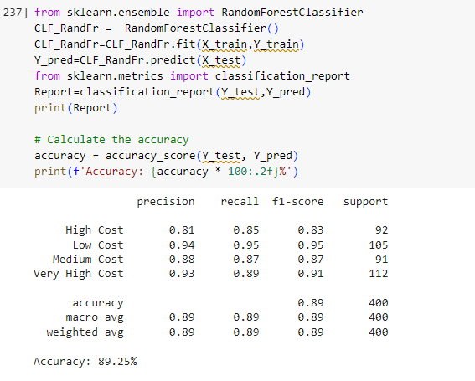

**4. Bagging Classifier**

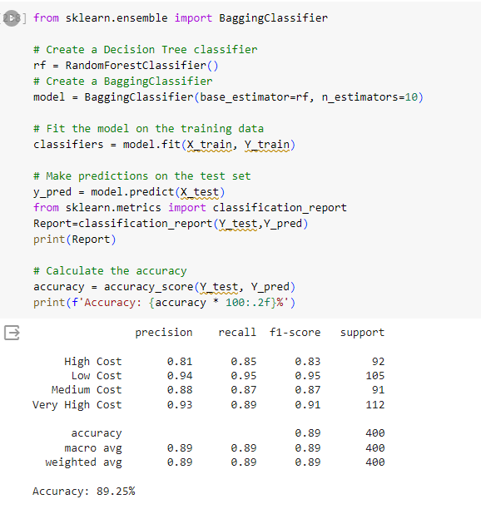

**5. Decision Tree Classifier**

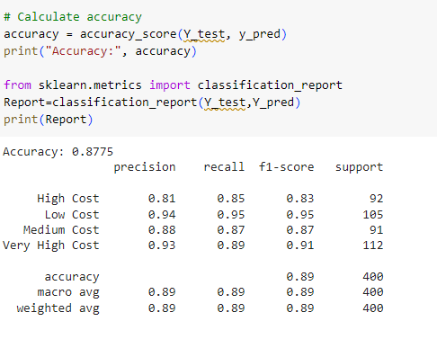

So, SVC classifier is having the best accuracy and below is the price_range predictions for test.csv data

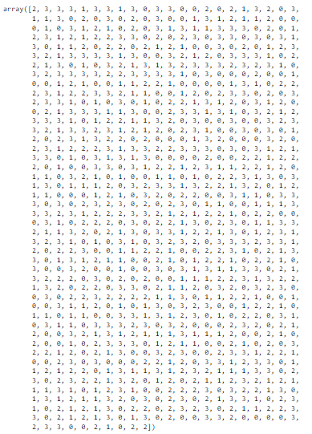

array(['Very High Cost', 'Very High Cost', 'High Cost', 'Very High Cost',

'Medium Cost', 'Very High Cost', 'Very High Cost', 'Medium Cost',

'Very High Cost', 'Low Cost', 'Very High Cost', 'Very High Cost',

'Low Cost', 'Low Cost', 'High Cost', 'Low Cost', 'High Cost',

'Medium Cost', 'Very High Cost', 'High Cost', 'Medium Cost',

'Very High Cost', 'Medium Cost', 'Medium Cost', 'Very High Cost',

'Low Cost', 'High Cost', 'Low Cost', 'Very High Cost', 'Low Cost',

'High Cost', 'Low Cost', 'Very High Cost', 'Low Cost',

'Medium Cost', 'Medium Cost', 'Very High Cost', 'Medium Cost',

'High Cost', 'Medium Cost', 'Medium Cost', 'High Cost', 'Low Cost',

'Low Cost', 'Low Cost', 'Medium Cost', 'Low Cost',

'Very High Cost', 'Medium Cost', 'High Cost', 'Medium Cost',

'Low Cost', 'Very High Cost', 'Low Cost', 'Very High Cost',

'Medium Cost', 'Very High Cost', 'Medium Cost', 'Medium Cost',

'Very High Cost', 'Very High Cost', 'Very High Cost', 'Low Cost',

'Medium Cost', 'Medium Cost', 'Medium Cost', 'Medium Cost',

'Very High Cost', 'Medium Cost', 'High Cost', 'Medium Cost',

'High Cost', 'High Cost', 'Very High Cost', 'Very High Cost',

'Low Cost', 'High Cost', 'Low Cost', 'High Cost', 'Very High Cost',

'Low Cost', 'Very High Cost', 'Very High Cost', 'Low Cost',

'Very High Cost', 'Low Cost', 'Very High Cost', 'Medium Cost',

'Very High Cost', 'Low Cost', 'Medium Cost', 'High Cost',

'High Cost', 'Medium Cost', 'High Cost', 'High Cost', 'Low Cost',

'High Cost', 'Medium Cost', 'High Cost', 'Medium Cost', 'Low Cost',

'Low Cost', 'Very High Cost', 'Low Cost', 'High Cost', 'Low Cost',

'Medium Cost', 'High Cost', 'Very High Cost', 'Very High Cost',

'Very High Cost', 'Medium Cost', 'Very High Cost',

'Very High Cost', 'Very High Cost', 'Very High Cost', 'High Cost',

'Very High Cost', 'Low Cost', 'Low Cost', 'Very High Cost',

'High Cost', 'Medium Cost', 'High Cost', 'Low Cost',

'Very High Cost', 'High Cost', 'Very High Cost', 'Medium Cost',

'Low Cost', 'High Cost', 'High Cost', 'Medium Cost',

'Very High Cost', 'Medium Cost', 'Medium Cost', 'Low Cost',

'Very High Cost', 'High Cost', 'Medium Cost', 'High Cost',

'Medium Cost', 'High Cost', 'High Cost', 'Very High Cost',

'Very High Cost', 'Very High Cost', 'High Cost', 'Very High Cost',

'High Cost', 'Very High Cost', 'Medium Cost', 'Low Cost',

'Very High Cost', 'High Cost', 'Very High Cost', 'Very High Cost',

'Very High Cost', 'Very High Cost', 'High Cost', 'High Cost',

'Very High Cost', 'Very High Cost', 'Very High Cost',

'Very High Cost', 'Medium Cost', 'Low Cost', 'Very High Cost',

'Low Cost', 'Low Cost', 'Low Cost', 'High Cost', 'Medium Cost',

'Low Cost', 'Medium Cost', 'Low Cost', 'Low Cost', 'Medium Cost',

'High Cost', 'Medium Cost', 'Low Cost', 'Low Cost', 'Medium Cost',

'Medium Cost', 'High Cost', 'High Cost', 'Medium Cost', 'Low Cost',

'Low Cost', 'Low Cost', 'Medium Cost', 'Low Cost',

'Very High Cost', 'Medium Cost', 'Low Cost', 'High Cost',

'High Cost', 'High Cost', 'Very High Cost', 'Medium Cost',

'Medium Cost', 'Very High Cost', 'High Cost', 'Very High Cost',

'High Cost', 'High Cost', 'Medium Cost', 'Low Cost', 'Low Cost',

'Medium Cost', 'High Cost', 'Low Cost', 'High Cost',

'Very High Cost', 'Very High Cost', 'Low Cost', 'High Cost',

'Low Cost', 'Very High Cost', 'High Cost', 'Very High Cost',

'Very High Cost', 'Medium Cost', 'Low Cost', 'Medium Cost',

'Low Cost', 'Very High Cost', 'Low Cost', 'Medium Cost',

'Low Cost', 'High Cost', 'High Cost', 'Medium Cost', 'High Cost',

'Low Cost', 'Very High Cost', 'Low Cost', 'Very High Cost',

'Medium Cost', 'High Cost', 'Low Cost', 'Low Cost', 'High Cost',

'Medium Cost', 'Very High Cost', 'Very High Cost',

'Very High Cost', 'Medium Cost', 'Medium Cost', 'Very High Cost',

'Low Cost', 'Low Cost', 'High Cost', 'Very High Cost',

'Very High Cost', 'Medium Cost', 'Very High Cost', 'Medium Cost',

'Medium Cost', 'Very High Cost', 'High Cost', 'Medium Cost',

'High Cost', 'Very High Cost', 'Very High Cost', 'Very High Cost',

'Medium Cost', 'Low Cost', 'Medium Cost', 'High Cost',

'Very High Cost', 'Medium Cost', 'Medium Cost', 'Very High Cost',

'High Cost', 'Low Cost', 'Very High Cost', 'Low Cost', 'Low Cost',

'High Cost', 'Low Cost', 'Low Cost', 'Very High Cost', 'High Cost',

'Very High Cost', 'Very High Cost', 'High Cost', 'Medium Cost',

'Very High Cost', 'Very High Cost', 'High Cost', 'Very High Cost',

'Medium Cost', 'High Cost', 'Medium Cost', 'High Cost', 'Low Cost',

'High Cost', 'Very High Cost', 'Medium Cost', 'Low Cost',

'Low Cost', 'Very High Cost', 'Low Cost', 'Very High Cost',

'Low Cost', 'Medium Cost', 'High Cost', 'Low Cost', 'High Cost',

'Very High Cost', 'Medium Cost', 'Very High Cost', 'High Cost',

'High Cost', 'Medium Cost', 'High Cost', 'Low Cost', 'Low Cost',

'Low Cost', 'Medium Cost', 'Very High Cost', 'High Cost',

'Low Cost', 'Low Cost', 'Low Cost', 'Very High Cost', 'High Cost',

'Low Cost', 'High Cost', 'Very High Cost', 'Medium Cost',

'High Cost', 'High Cost', 'High Cost', 'Very High Cost',

'Medium Cost', 'Very High Cost', 'Very High Cost', 'High Cost',

'High Cost', 'High Cost', 'Very High Cost', 'Very High Cost',

'Low Cost', 'Very High Cost', 'Low Cost', 'Very High Cost',

'Medium Cost', 'Very High Cost', 'Medium Cost', 'Very High Cost',

'Very High Cost', 'Low Cost', 'Medium Cost', 'Low Cost',

'Very High Cost', 'Medium Cost', 'Very High Cost', 'High Cost',

'Very High Cost', 'Low Cost', 'Low Cost', 'Low Cost', 'Low Cost',

'High Cost', 'Low Cost', 'Low Cost', 'High Cost', 'High Cost',

'Medium Cost', 'High Cost', 'High Cost', 'High Cost', 'Low Cost',

'Medium Cost', 'Low Cost', 'Low Cost', 'Very High Cost',

'High Cost', 'Low Cost', 'Very High Cost', 'Medium Cost',

'High Cost', 'High Cost', 'Medium Cost', 'High Cost',

'Very High Cost', 'Medium Cost', 'Medium Cost', 'High Cost',

'High Cost', 'Medium Cost', 'High Cost', 'Low Cost', 'Medium Cost',

'Medium Cost', 'Low Cost', 'Very High Cost', 'High Cost',

'Low Cost', 'Low Cost', 'Medium Cost', 'Low Cost', 'Low Cost',

'Medium Cost', 'Medium Cost', 'Low Cost', 'Low Cost', 'Low Cost',

'High Cost', 'High Cost', 'Very High Cost', 'High Cost',

'Very High Cost', 'Low Cost', 'Very High Cost', 'Low Cost',

'Very High Cost', 'Low Cost', 'Medium Cost', 'Medium Cost',

'Medium Cost', 'High Cost', 'Low Cost', 'Very High Cost',

'High Cost', 'Very High Cost', 'Very High Cost', 'Medium Cost',

'Very High Cost', 'Medium Cost', 'Very High Cost', 'Medium Cost',

'Very High Cost', 'High Cost', 'Low Cost', 'Medium Cost',

'High Cost', 'Medium Cost', 'Medium Cost', 'Low Cost', 'Low Cost',

'Low Cost', 'Medium Cost', 'High Cost', 'Medium Cost', 'Low Cost',

'Very High Cost', 'High Cost', 'Low Cost', 'High Cost',

'High Cost', 'Low Cost', 'Low Cost', 'Very High Cost',

'Medium Cost', 'High Cost', 'Low Cost', 'Very High Cost',

'High Cost', 'Very High Cost', 'Low Cost', 'Very High Cost',

'Low Cost', 'High Cost', 'Very High Cost', 'Very High Cost',

'Very High Cost', 'Low Cost', 'High Cost', 'Low Cost', 'High Cost',

'Very High Cost', 'Low Cost', 'Medium Cost', 'Medium Cost',

'Low Cost', 'Low Cost', 'Medium Cost', 'Medium Cost',

'Medium Cost', 'Very High Cost', 'Very High Cost',

'Very High Cost', 'High Cost', 'Very High Cost', 'Medium Cost',

'High Cost', 'High Cost', 'Very High Cost', 'Very High Cost',

'Very High Cost', 'High Cost', 'Low Cost', 'High Cost',

'Medium Cost', 'High Cost', 'High Cost', 'Medium Cost', 'Low Cost',

'High Cost', 'High Cost', 'Low Cost', 'Low Cost', 'Low Cost',

'Very High Cost', 'Medium Cost', 'Low Cost', 'High Cost',

'High Cost', 'High Cost', 'Low Cost', 'Very High Cost', 'Low Cost',

'High Cost', 'High Cost', 'Medium Cost', 'Very High Cost',

'Low Cost', 'High Cost', 'Very High Cost', 'Low Cost',

'Medium Cost', 'Medium Cost', 'Very High Cost', 'Very High Cost',

'Medium Cost', 'Medium Cost', 'High Cost', 'Very High Cost',

'High Cost', 'Low Cost', 'High Cost', 'Medium Cost', 'High Cost',

'Low Cost', 'Very High Cost', 'Very High Cost', 'Medium Cost',

'High Cost', 'High Cost', 'High Cost', 'Very High Cost',

'Low Cost', 'Medium Cost', 'High Cost', 'Very High Cost',

'Medium Cost', 'Very High Cost', 'High Cost', 'Very High Cost',

'Medium Cost', 'Medium Cost', 'Medium Cost', 'Low Cost',

'Very High Cost', 'Medium Cost', 'Low Cost', 'Very High Cost',

'High Cost', 'Very High Cost', 'High Cost', 'Low Cost',

'Very High Cost', 'Very High Cost', 'Very High Cost', 'High Cost',

'Very High Cost', 'Very High Cost', 'Medium Cost', 'High Cost',

'Low Cost', 'High Cost', 'Very High Cost', 'Very High Cost',

'Medium Cost', 'Low Cost', 'Medium Cost', 'Medium Cost',

'High Cost', 'High Cost', 'High Cost', 'Low Cost', 'Low Cost',

'High Cost', 'High Cost', 'Very High Cost', 'High Cost',

'Low Cost', 'High Cost', 'Medium Cost', 'Very High Cost',

'Very High Cost', 'Low Cost', 'Medium Cost', 'Very High Cost',

'Low Cost', 'High Cost', 'Medium Cost', 'Medium Cost', 'Low Cost',

'Low Cost', 'High Cost', 'Medium Cost', 'Low Cost', 'Medium Cost',

'Medium Cost', 'High Cost', 'High Cost', 'Low Cost', 'High Cost',

'High Cost', 'Medium Cost', 'Low Cost', 'Very High Cost',

'Low Cost', 'Low Cost', 'Very High Cost', 'High Cost', 'Low Cost',

'Low Cost', 'Low Cost', 'Low Cost', 'Low Cost', 'Very High Cost',

'Low Cost', 'Very High Cost', 'Medium Cost', 'Very High Cost',

'High Cost', 'Medium Cost', 'Very High Cost', 'Very High Cost',

'Low Cost', 'Medium Cost', 'Low Cost', 'Very High Cost',

'High Cost', 'High Cost', 'High Cost', 'Low Cost',

'Very High Cost', 'Low Cost', 'High Cost', 'Low Cost', 'High Cost',

'Low Cost', 'Low Cost', 'Medium Cost', 'Medium Cost',

'Medium Cost', 'High Cost', 'Medium Cost', 'Very High Cost',

'Medium Cost', 'Very High Cost', 'High Cost', 'High Cost',

'Medium Cost', 'Very High Cost', 'High Cost', 'Low Cost',

'Medium Cost', 'High Cost', 'Low Cost', 'Very High Cost',

'Very High Cost', 'Low Cost', 'High Cost', 'Medium Cost',

'Medium Cost', 'High Cost', 'Low Cost', 'Very High Cost',

'High Cost', 'Low Cost', 'Very High Cost', 'High Cost',

'Very High Cost', 'Low Cost', 'Low Cost', 'Very High Cost',

'Low Cost', 'High Cost', 'High Cost', 'Very High Cost',

'High Cost', 'High Cost', 'High Cost', 'High Cost', 'Medium Cost',

'High Cost', 'Very High Cost', 'Low Cost', 'Medium Cost',

'Low Cost', 'Medium Cost', 'High Cost', 'Medium Cost', 'Low Cost',

'Low Cost', 'Medium Cost', 'Low Cost', 'Low Cost',

'Very High Cost', 'Low Cost', 'Medium Cost', 'High Cost',

'Low Cost', 'Low Cost', 'Medium Cost', 'Medium Cost',

'Very High Cost', 'Low Cost', 'Very High Cost', 'High Cost',

'Very High Cost', 'Low Cost', 'Low Cost', 'Medium Cost',

'High Cost', 'High Cost', 'Medium Cost', 'Low Cost', 'Medium Cost',

'Medium Cost', 'Low Cost', 'Medium Cost', 'Medium Cost',

'Low Cost', 'Low Cost', 'Very High Cost', 'Very High Cost',

'Low Cost', 'Very High Cost', 'Medium Cost', 'Medium Cost',

'Very High Cost', 'Low Cost', 'Medium Cost', 'Low Cost',

'High Cost', 'High Cost', 'Low Cost', 'Very High Cost',

'Medium Cost', 'Low Cost', 'Very High Cost', 'Low Cost',

'Medium Cost', 'Low Cost', 'Very High Cost', 'Very High Cost',

'Very High Cost', 'High Cost', 'Very High Cost', 'Low Cost',

'Very High Cost', 'High Cost', 'Low Cost', 'Low Cost', 'Low Cost',

'High Cost', 'Very High Cost', 'High Cost', 'Low Cost',

'High Cost', 'Medium Cost', 'High Cost', 'Low Cost', 'Low Cost',

'Very High Cost', 'High Cost', 'Low Cost', 'Very High Cost',

'Medium Cost', 'High Cost', 'Medium Cost', 'Medium Cost',

'Medium Cost', 'Very High Cost', 'Medium Cost', 'Medium Cost',

'Medium Cost', 'High Cost', 'Medium Cost', 'Low Cost', 'High Cost',

'High Cost', 'Low Cost', 'High Cost', 'Low Cost', 'Low Cost',

'Low Cost', 'Low Cost', 'High Cost', 'Very High Cost',

'Very High Cost', 'Very High Cost', 'Low Cost', 'Medium Cost',

'High Cost', 'Medium Cost', 'Medium Cost', 'Low Cost', 'Low Cost',

'High Cost', 'Medium Cost', 'Low Cost', 'High Cost', 'Low Cost',

'Very High Cost', 'High Cost', 'High Cost', 'Medium Cost',

'High Cost', 'Low Cost', 'High Cost', 'Medium Cost',

'Very High Cost', 'Low Cost', 'Low Cost', 'Very High Cost',

'High Cost', 'Very High Cost', 'Low Cost', 'Low Cost', 'High Cost',

'Very High Cost', 'Very High Cost', 'Medium Cost', 'High Cost',

'High Cost', 'Medium Cost', 'Low Cost', 'Low Cost', 'High Cost',

'Very High Cost', 'Low Cost', 'Very High Cost', 'Low Cost',

'Low Cost', 'Low Cost', 'High Cost', 'High Cost', 'Medium Cost',

'High Cost', 'Low Cost', 'Very High Cost', 'High Cost',

'Medium Cost', 'High Cost', 'Very High Cost', 'Very High Cost',

'Low Cost', 'Medium Cost', 'Medium Cost', 'High Cost',

'Medium Cost', 'High Cost', 'High Cost', 'Low Cost', 'Medium Cost',

'Very High Cost', 'Medium Cost', 'Medium Cost', 'Very High Cost',

'Medium Cost', 'High Cost', 'Very High Cost', 'High Cost',

'Medium Cost', 'Medium Cost', 'Medium Cost', 'Very High Cost',

'Very High Cost', 'Low Cost', 'High Cost', 'Very High Cost',

'Low Cost', 'High Cost', 'Very High Cost', 'Very High Cost',

'High Cost', 'High Cost', 'Very High Cost', 'High Cost',

'Low Cost', 'Medium Cost', 'High Cost', 'Low Cost', 'High Cost',

'Medium Cost', 'Medium Cost', 'High Cost', 'High Cost',

'High Cost', 'Medium Cost', 'High Cost', 'Medium Cost', 'Low Cost',

'Medium Cost', 'Very High Cost', 'Medium Cost', 'Low Cost',

'Medium Cost', 'High Cost', 'Very High Cost', 'Medium Cost',

'Low Cost', 'Low Cost', 'Very High Cost', 'High Cost', 'High Cost',

'Very High Cost', 'Low Cost', 'Very High Cost', 'Very High Cost',

'High Cost', 'Medium Cost', 'Very High Cost', 'Low Cost',

'Medium Cost', 'Very High Cost', 'Medium Cost', 'Medium Cost',

'Medium Cost', 'Medium Cost', 'Very High Cost', 'High Cost',

'Low Cost', 'Very High Cost', 'Low Cost', 'High Cost',

'Very High Cost', 'Low Cost', 'Very High Cost', 'High Cost',

'Very High Cost', 'Very High Cost', 'Medium Cost', 'Low Cost',

'High Cost', 'Very High Cost', 'Medium Cost', 'Low Cost',

'High Cost', 'Medium Cost', 'High Cost', 'Medium Cost',

'High Cost', 'Low Cost', 'High Cost', 'High Cost', 'Low Cost',

'High Cost', 'Very High Cost', 'High Cost', 'Very High Cost',

'Low Cost', 'High Cost', 'Medium Cost', 'Medium Cost', 'High Cost',

'High Cost', 'Very High Cost', 'Very High Cost', 'Low Cost',

'High Cost', 'Medium Cost', 'High Cost', 'Medium Cost',

'Very High Cost', 'Medium Cost', 'Medium Cost', 'Very High Cost',

'Low Cost', 'Medium Cost', 'Low Cost', 'Low Cost',

'Very High Cost', 'Very High Cost', 'High Cost', 'Low Cost',

'Low Cost', 'Low Cost', 'Low Cost', 'Very High Cost', 'High Cost',

'Very High Cost', 'Very High Cost', 'Low Cost', 'Low Cost',

'High Cost', 'Medium Cost', 'Low Cost', 'High Cost', 'High Cost'],

dtype=object)

CodeText